# TC1 Rev1 Assembly Guide

TOP SIDE BOTTOM SIDE

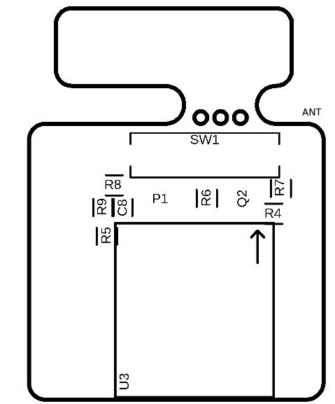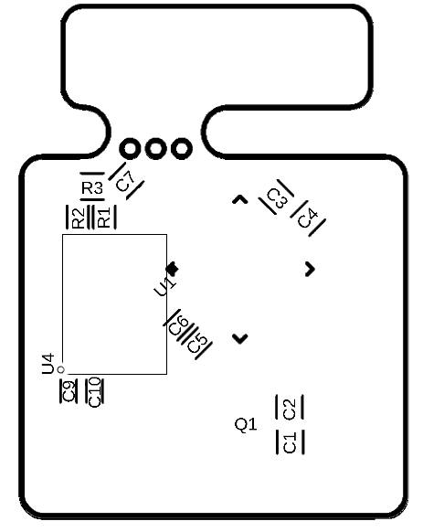

|  |  |  |  |  |
| --- | --- | --- | --- | --- |
| Qty | Value | Footprint | Package | Designator |
| 7 | 0.1uF | C_CHIP-0402 | CAPC1005X60 | C3 to C7, C9, C10 |
| 8 | 10k | R_CHIP-0402 | RESC1005X40 | R1 to R8 |
| 2 | 10pF | C_CHIP-0402 | CAPC1005X60 | C1, C2 |
| 1 | 1uF | C_CHIP-0402 | CAPC1005X60 | C8 |
| 1 | 22k | R_CHIP-0402 | RESC1005X40 | R9 |
| 1 | 8mhz | CRYSTAL | CRYSTAL_NX3225GD | Q1 |
| 1 | ATMEGA328P-MU | ATMEGA328P-MU | QFN32_5X5_0.50 | U1 |
| 1 | DS3231MZ+ | DS3231MZ+ | DS3231MZ+_SOIC8 | U4 |
| 1 | GPS_ORG1411 | GPS_ORG1411 | ORG1411 | U3 |
| 1 | LDO_MIC5205YM5 | LDO_MIC5205YM5 | MIC5205 | P1 |
| 1 | NMOSFET | NMOSFETSOT23 | SOT23 | Q2 |
| 1 | REED_SWITCH | REED_SWITCH | REED_CT05 | SW1 |

Notes-

* U3 pin 1 has a longer pad than the others. Pin 1 pad is near upwards pointing arrow on Top side.

# Programming Pinouts

